**Perform Data Analysis in Power BI**

**Lab story**

In this lab, you'll create the **Sales Exploration** report.

In this lab you learn how to:

* Create animated scatter charts
* Use a visual to forecast values

**This lab should take approximately 30 minutes.**

**Get started – Sign in**

In this task, you'll set up the environment for the lab by signing in to Power BI.

*Note: If you've already signed in to Power BI, skip to the next task.*

1. To open Microsoft Edge, on the taskbar, select the Microsoft Edge program shortcut.

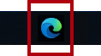

1. In the Microsoft Edge browser window, navigate to **https://app.powerbi.com**.

*Tip: You can also use the Power BI Service favorite on the Microsoft Edge favorites bar.*

1. Complete the sign-in process with your organizational (or provided) credentials. If prompted by Microsoft Edge to stay signed in, select **Yes**.
2. In the Microsoft Edge browser window, in the Power BI service, in the **Navigation** pane, expand **My Workspace**. Leave the Microsoft Edge browser window open.

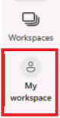

**Get started – Create a dataset**

In this task, you'll set up the environment for the lab by creating a dataset. *If you've already published the dataset, please move to the next task.*

1. In the Microsoft Edge browser window, in the Power BI service, navigate to **My Workspace**.
2. Select **Upload > Browse**.
3. Navigate to **D:\PL300\Labs\08-perform-data-analysis-in-power-bi-desktop\Starter** folder.
4. Select the **Sales Analysis.pbix** file, and then select **Open**.

*If prompted to replace the dataset, select****Replace it****.*

*This method will create a report and a dataset. We will only use the dataset to create a new report in this exercise. This same process could be done with an existing dataset from a different report instead of uploading new. Also, if you aren't using the report, workspace best practices suggest you delete the unnecessary file.*

**Create the report**

In this task, you'll create a live connection to the Power BI dataset created in the last task, and then create a new **Sales Exploration** report.

1. Open Power BI Desktop.

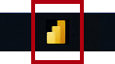

*Important: If you already have Power BI Desktop open (from a previous lab), close that instance.*

*Tip: By default, the Getting Started dialog box opens in front of Power BI Desktop. You can choose to sign-in, and then close the pop-up.*

1. In the Home ribbon, select **Get Data > Power BI datasets**.
2. In the **Data hub** window, select the **Sales Analysis** dataset in **My Workspace**, and then **Connect** or double-click to load the dataset.
3. Navigate to **File > Save** and save the file name as **Sales Exploration** in the **D:\PL300\MySolution** folder.

*You’ll now create two report pages, and on each page you’ll work with a different visual to analyze and explore data.*

**Create an animated scatter chart**

In this task, you'll create a scatter chart that can be animated.

1. Rename **Page 1** as **Scatter Chart**.
2. Add a **Scatter Chart** visual to the report page, and then position and resize it so it fills the entire page.

*The chart can be animated when a field is added to the****Play Axis****well/area.*

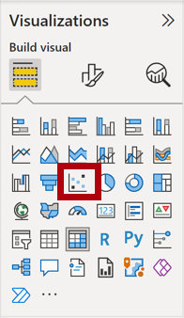



1. Add the following fields to the visual wells/areas:

*The labs use a shorthand notation to reference a field. It will look like this:****Reseller******|******Business Type****. In this example,****Reseller****is the table name and****Business Type****is the field name.*

* + X Axis: **Sales | Sales**
  + Y Axis: **Sales | Profit Margin**
  + Legend: **Reseller | Business Type**
  + Size: **Sales | Quantity**
  + Play Axis: **Date | Quarter**

1. In the **Filters** pane, add the **Product | Category** field to the **Filters On This Page** well/area.
2. In the filter card, filter by **Bikes**.
3. To animate the chart, at the bottom left corner, select **Play**.

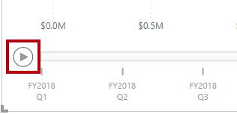

1. Watch the entire animation cycle from **FY2018 Q1** to **FY2020 Q4**.

*The scatter chart allows understanding the measure values simultaneously: in this case, order quantity, sales revenue, and profit margin.*

*Each bubble represents a reseller business type. Changes in the bubble size reflect increased or decreased order quantities. While horizontal movements represent increases/decreases in sales revenue, and vertical movements represent increases/decreases in profitability.*

1. When the animation stops, select one of the bubbles to reveal its tracking over time.
2. Hover the cursor over any bubble to reveal a tooltip describing the measure values for the reseller type at that point in time.
3. In the **Filters** pane, filter by **Clothing** only, and notice that it produces a very different result.
4. Save the Power BI Desktop file.

**Create a forecast**

In this task, you'll create a forecast to determine possible future sales revenue.

1. Add a new page, and then rename the page to **Forecast**.
2. Add a **Line Chart** visual to the report page, and then position and resize it so it fills the entire page.

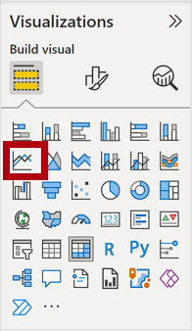



1. Add the following fields to the visual wells/areas:
   * X-axis: **Date | Date**
   * Y-axis: **Sales | Sales**
2. In the **Filters** pane, add the **Date | Year** field to the **Filters On This Page** well/area.
3. In the filter card, filter by two years: **FY2019** and **FY2020**.

*When forecasting over a time line, you'll need at least two cycles (years) of data to produce an accurate and stable forecast.*

1. Add also the **Product | Category** field to the **Filters On This Page** well/area, and filter by **Bikes**.
2. To add a forecast, beneath the **Visualizations** pane, select the **Analytics** pane.

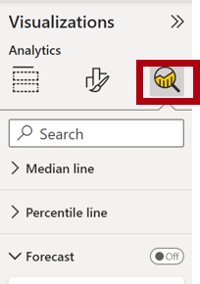

1. Expand the **Forecast** section.

*If the****Forecast****section isn't available, it’s probably because the visual hasn’t been correctly configured. Forecasting is only available when two conditions are met: the axis has a single field of type date, and there’s only one value field.*

1. Turn the **Forecast** option to **On**.
2. Configure the following forecast properties, then **Apply**:
   * Units: **Months**
   * Forecast length: **1 month**
   * Seasonality: **365**
   * Confidence interval: **80%**

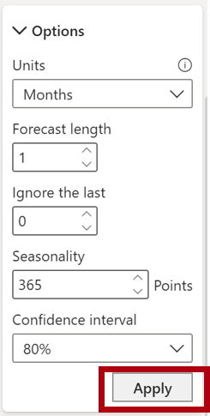

1. In the line visual, notice that the forecast has extended one month beyond the history data.

*The gray area represents the confidence. The wider the confidence, the less stable—and therefore the less accurate—the forecast is likely to be.*

*When you know the length of the cycle, in this case annual, you should enter the seasonality points. Sometimes it could be weekly (7), or monthly (30).*

1. In the **Filters** pane, filter by **Clothing** only, and notice that it produces a different result.

**Finish up**

In this task, you'll complete the lab in Power BI Desktop.

1. Select the **Scatter Chart** page.
2. Save the Power BI Desktop file.
3. To publish the file to your **My workspace**, on the **Home** ribbon tab, from inside the **Share** group, select **Publish** and then select **Select** to publish.

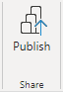

1. Close Power BI Desktop.